Photogrammetric Computer Vision

Assignment 4

Group K

We have paired two different viewing images of the same object from two different positions.

We measure 8 points and generated Fundamental Matrix and finally drew epipolar lines. From our measurement,

The geometric image error is



using the Sampson distance.

While we did the SVD of design matrix to generate the Fundamental Matrix F, calculated epipolar lines and finally drew lines, we got the following findings:

* The lines we drew joined in a point.
* Low Geometric Image Error.

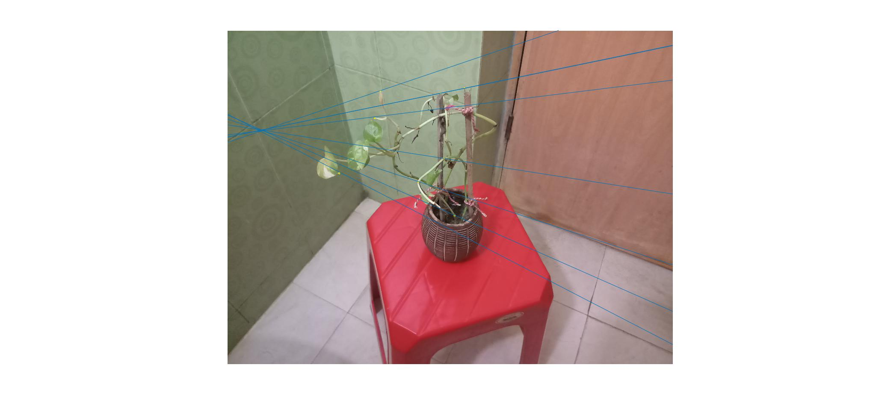

Thus, we can say that, F seems to have fulfilled the singularity constraint.